Pharmaceutical Medicine Supply System

**(TIMES NEW ROMAN FONT ,FONT SIZE 16 PT CENTERED)**

**Group Members**

BALLA HEMANTH (AM.EN.U4CSE20215) BEENEEDI ABHINAV (AM.EN.U4CSE20216) MUDIYALA VISHAL REDDY (AM.EN.U4CSE20248) V.V.S.N.SAI MOHAN (AM.EN.U4CSE20275)

**ABSTRACT**

Pharmacy management system is a management system that is designed to improve accuracy and to enhance safety and efficiency in the pharmaceutical store. It is a computer based system which helps the Pharmacist to improve inventory management, cost, medical safety etc.

The system allows us to enter a manufacturing and expiry date for a particular medicine. This application provides user login to the Company Manager. They can add information about medicines. And the Manager can get all expired medicines information and they are able to see all orders information of clients.

This application provides user login to the distributor. This application allows the distributor to know useful information about the particular medicine. And also keeps track of medicines which are going to expiry. The distributor needs to provide the number of medicines to be ordered. The main goal of this application is to provide the medicines to all the people & distributer will provide the supplier details.

***Keywords:*** Pharmacy , Medicine , Store , Application.

**Functional Requirements of the System:**

1. When you open our application, firstly it asks them to sign in of type or to register for a new user(not for admin registration). For the new user to register they have to enter their credentials. There are three login types: admin, distributor, pharmacist.
2. Users can login through their credentials.
3. There are separate databases for the admin, distributors, pharmacist.

**Functionalities of each actor:**

Here we provided 3 actors :

**Actor-1:** Admin

**Functionality:** Manage other accounts.

* Manages the accounts of both distributors and pharmacists.

**Actor-2:** Company Manager

**Functionality:** Manages Information of drugs.

* Stores and updates information on medicines.
* Communicate with the distributors.

**Actor-3:** Distributer

**Functionality:** Purchase medicines.

* He can view the availability of all medicines.
* He will keep shortlisting what products he wants.
* He will then move to the payment portal and receive an invoice.

**Use Case Description:**

|  |  |
| --- | --- |
| Use case ID | Login, Manage System Accounts |
| Actor | Admin |
| Description | Admin can manage the system accounts. Admin can actually see all the processes going through the server. |

|  |  |
| --- | --- |
| Use case ID | Login, Manage Details |
| Actor | Company Manager |
| Description | Company Managers can modify details of medicines like add, update or delete. They can search medicines and can keep track of expiry dates of medicines. They can view the invoices of all payments made. |

|  |  |
| --- | --- |
| Use case ID | Login, Register |
| Actor | Distributor |

|  |  |
| --- | --- |
| Description | Distributer can search for medicines and after selection they can add items to shortlist. And can keep track of expiry dates of medicines. Finally, they can order the medicines and make payments then receive invoice for that. |

**Use case Diagram**

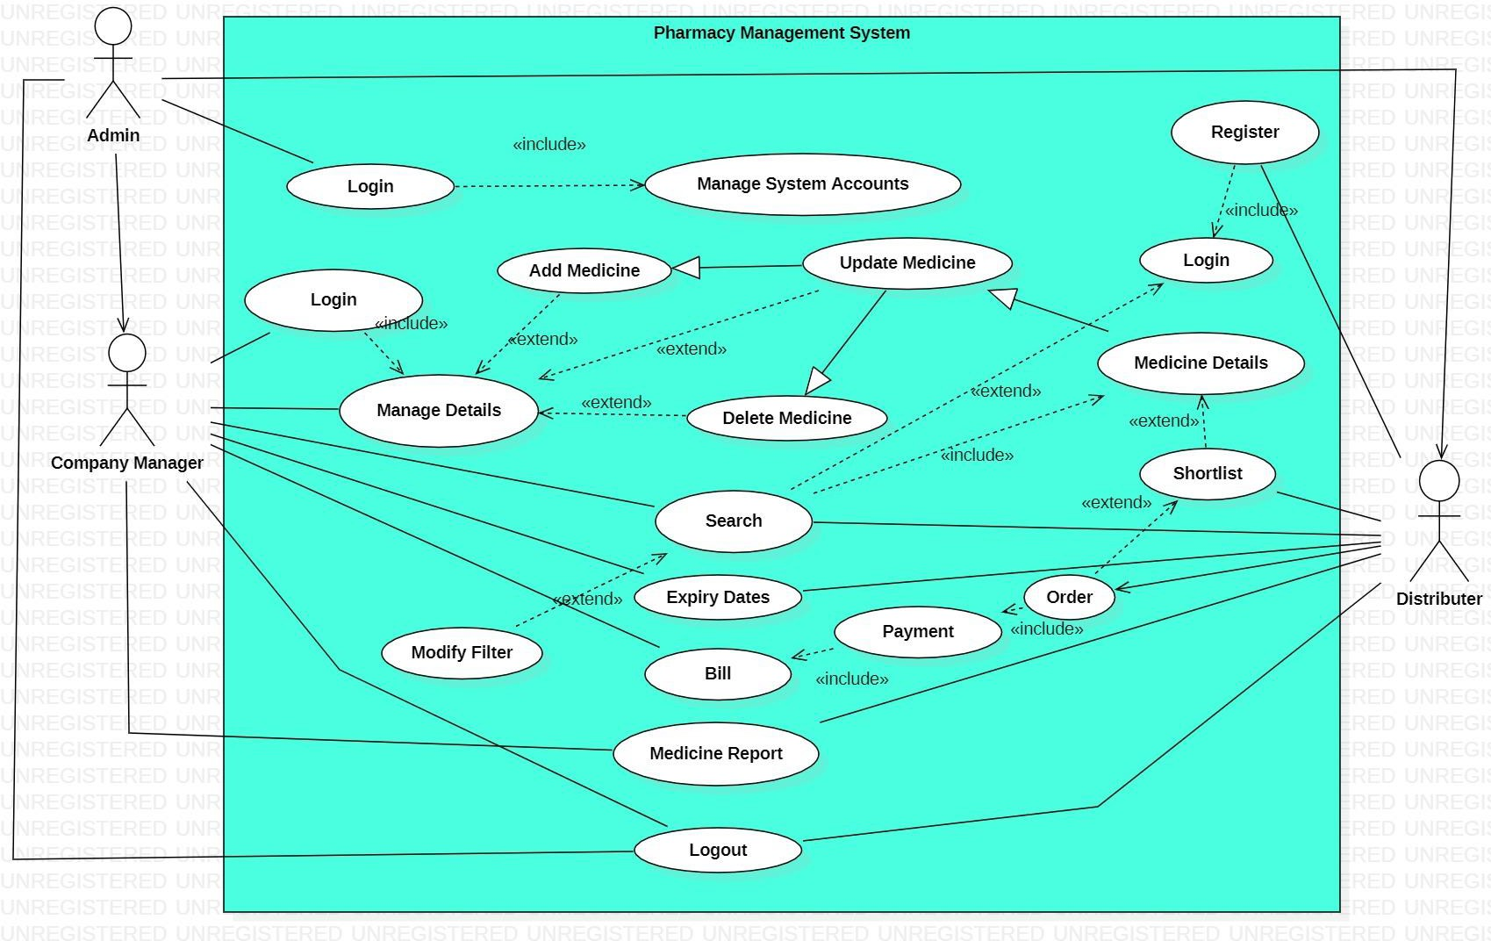

**Class Diagram**

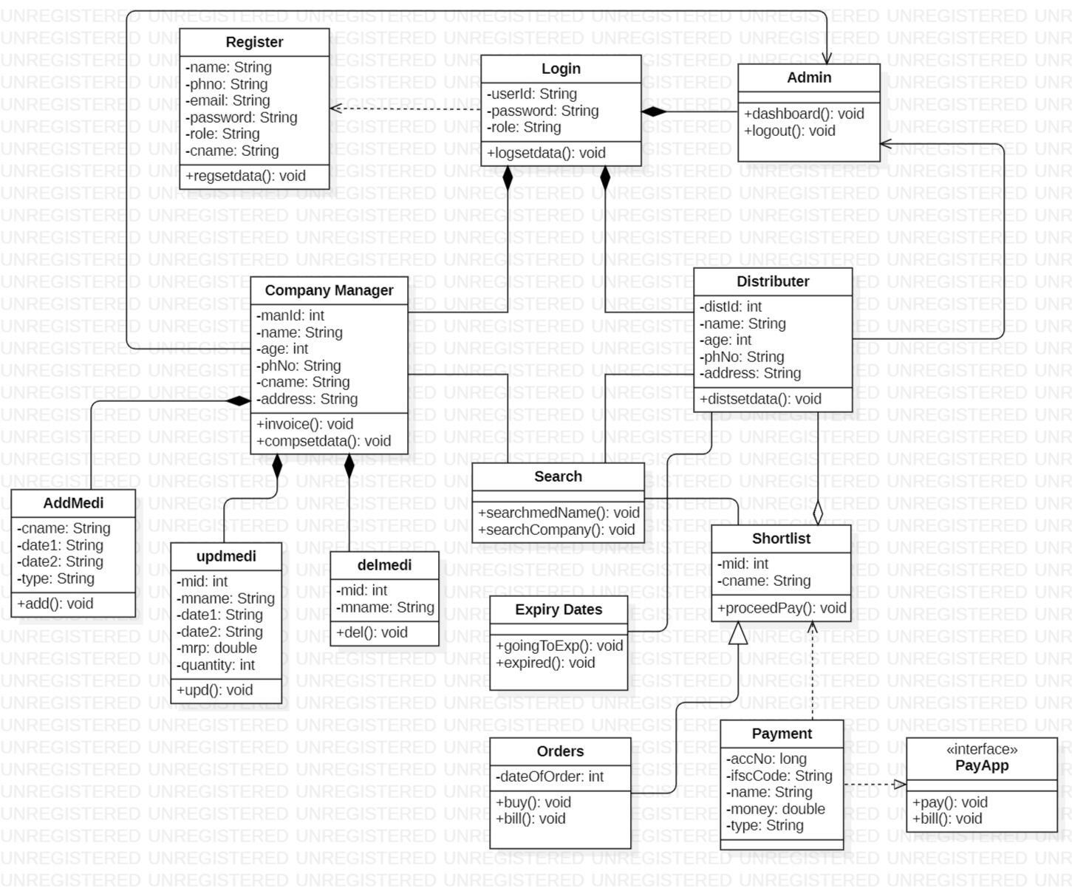

**User Interface Design:**

1. Login Page:

1. Register page:

1. Admin Page:

1. Company Manager Page:

1. Distributer Page:

1. Search (3 windows):

1. Add Medicine Page:

1. Delete Medicine Page:

1. Update Medicine Page:

1. Expiring Soon (table data):

______________________________________________________________

***\*We also uploaded a video of how our application works.***